9-6-15
“The Law of Liberty”

Scriptures:
James 2:1-24
Psalm 125:1-4
Mark 7:24-37

Over the last couple weeks I have been reading the news about the refugees leaving Syria and the Middle East by the hundreds of thousands. Finally, after days of feeling as though prayer was simply not enough, I sent an email to the General Secretary of the General Board of Global Missions of the United Methodist Church. I asked him if the United Methodist Committee on Relief had plans to intervene in the humanitarian disaster taking shape in the Eastern Mediterranean and Central Europe. His name is Thomas Kemper, and this was his reply:

“Thank you for your email. We are working on a larger response to the crisis at this moment and are in touch with our churches and partners in Europe. We already have done two specific projects this year: A food voucher distribution in Southern Italy for refugees and, currently, a food and hygiene kit distribution in Greece for 750 migrant families arriving primarily from Syria. This is in addition to the nearly $2 million that we’ve invested in programming more directly to support the refugees from the Syria-Iraq conflict. I am copying our UMCOR leadership for any additional information they might want to share. You will hear more about the widening response though our press releases in the next weeks.

In mission together,
Thomas G. Kemper”

Let us pray:

Most gracious God, out of all the words that will now be spoken and heard, may it be your Living Word that stays in our hearts. Give us the grace to receive it, and give us the charity to let all the other words slip away. We pray this in the name of Jesus Christ. Amen.

It’s a curious phrase that James puts to his audience – The Law of Liberty. To me these words seemed for so long like they did not go together. Laws bind us, and liberty means to be free. But what James means is written for us plainly – if we love our neighbors as ourselves, if we show mercy, we discover that what God commands us to do will give life to the world. It reminds me of the 23rd Psalm – “thy rod and thy staff, they comfort me.” Sounds strange does it not? But examine the metaphor: the shepherd walks behind the sheep and steers them away from the precipice, the ditch, the bear, and the wolf. The sheep don’t know that around a bend or two, and up over the next hill, there is a quiet place, out of the way of the wind, where a stream feeds a meadow of new grass…

The commandments of God – they comfort me…
the commandments of God make me to lie down in green pastures
the commandments of God restore my soul
the commandments of God place my feet on level paths
the commandments of God make a place for me among those who choose to be my
enemies
the commandments of God are gifts of grace that reveal God’s care and love…

The commandments of God are the Law of Liberty.

The convicting Word of the Covenant between God and God’s people is, at the same time, a word of grace. God’s judgment is never for our harm, but for our good. And, though hell is very real, hell is not God’s instrument of punishment, but the world which is created when humans disregard the One who alone knows the way to the pasture and the spring.

Dear friends, the Good News is very plain in the end… hear it now again:

God, the Father/Mother, sent the Holy Spirit into the grave
to give the crucified Son new and everlasting life,
so that in him the world might perceive the Glory of God
and know
that the fear of Death which drives us to hate may be laid aside for ever.

This is the Good News for we had lost our ability to trust. And to rehabilitate us and empower us to trust anew that God is God, Jesus risked everything in Gethsemane. Jesus staked his life on the Law of Liberty: in the face of Death, even death on a cross, Jesus refused to worship any thing or any one besides the One he new as Abba, Father. And was his trust not vindicated in the resurrection? Is this not the same trust which he learned in the human experience of wandering, homelessness, hunger, fatigue, frustration, irritation, and doubt.

We don’t pay enough attention to the humanity of Jesus, or spend time pondering the reality that Jesus had to mature in his faith just like us. Most of the time, we go from perfect little baby Jesus to victorious Resurrected Jesus. Christmas and Easter are much more marketable than the Cross after all. think But this version of Jesus isn’t very human is it? So let us be thankful that here in Mark’s gospel, the author gives us the most beautiful window into the process of sanctification that leads Jesus from his Baptism, through to the Cross, to the renewal of God’s everlasting life.

Let us study this gospel story for a moment and observe the man who taught James the meaning of the Law of Liberty.
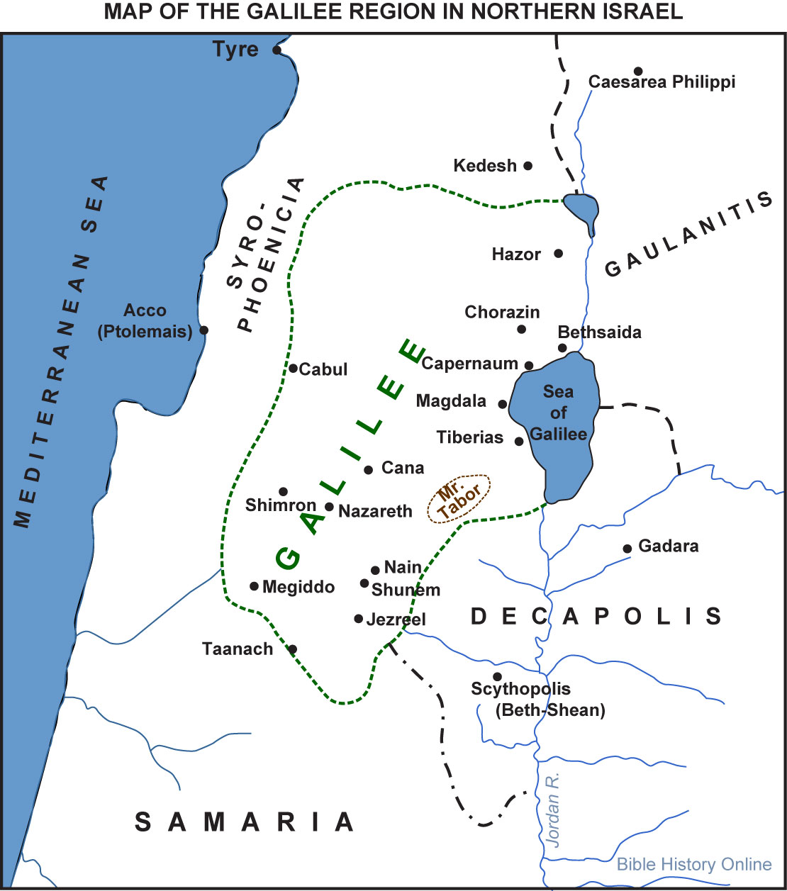
Map:
- Jesus has been on the western side of the sea of Galilee; and before that he had the feeding of the 5000 when he was supposed to be on holiday.
- So Jesus and the disciples haven’t had a rest in a while, they haven’t been able to recuperate – and Jesus says, “Let’s get out of Israel!” and they head for southern Syria.
- Look at Tyre – way up in the north west – it would have taken them days to walk there.
- They arrive and are utterly exhausted, and the mission isn’t going very well: the Pharisees are hypocrites, the disciples are thick-headed, and the people exhibit unending physical, emotional, and spiritual need.
- They find the one Jewish guy in Tyre from Nazareth and bed down for the night.
- But one of the servants in the house runs straight out and tells the neighbors, “Hey a prophet of great power is here from Galilee where he has brought the whole community together – they say he got 5000 people to share what they had and they fed everybody without spending a penny…”
- And a desperate mother doesn’t wait to hear any more, but runs for the life of her child, and falls down and begs…
- But she’s a gentile, and even though Jesus has just finished telling the Pharisees from Jerusalem that their traditions are a lot of cooked-up nonsense – he plays favorites…
- In his fatigue, frustration, and doubt he rebukes her and calls her a dog – this isn’t precious perfect Jesus is it? No – this is a man who is fully human and who is out of touch with the One he knows to be his Father, a man who has forgotten the Law of Liberty just long enough to be cruel.
- But in this moment, that thing which will conquer all the world’s cruelty transfigures him anew: Love – a mother’s love for her dying child…
- And Jesus remembers…and his heart breaks again for the suffering of this women; and, like the 5000 upon whom he looked with compassion in their need, he empties himself of his justified self-righteousness and responds to the fact that she is like a sheep without a shepherd… she does not know the way to the pasture where her daughter may be cleansed and healed…

Love – Love – Love ….

Love conquers all cruelty and brokenness.
Love sanctifies us as it passes through us.
Love cannot be possessed.
Love cannot be manipulated.

Love can only be obeyed – Love can only be obeyed – Love can only be obeyed.

And what we obey is that which is most natural to us: that wide-eyed, effortless, heartbreaking, instinctive willingness to be with other people in their fears, their needs, their frustrations, their doubts, their suffering, their poverty, and – yes – their death. As it passes through us, Love is what saves us from the hell and nothingness we humans make for ourselves in disobedience, for – as James so aptly puts it – “mercy triumphs over judgment.”

I received another email after the one from Thomas Kemper. It was from Denise Honeycutt, who is the Deputy General Secretary of the United Methodist Committee On Relief. This was her response to my correspondence with Rev. Kemper:

“Rev. Carle.
I wanted to also let you know that the European Methodist Council will be meeting next week, from which it is our expectation that more concerted responses to the refugee and migrant situation will be named. Congregations are encouraged, of course, to pray for all the refugees and migrants as they flow through Europe, and those wishing to give to UMCOR's continued work in this international crisis should give to Advance #982450.

Please thank the faithful folks of Trinity for their support and care for the most vulnerable in our world.

Peace,
J. Denise Honeycutt”

In a moment you will have an opportunity to give a special offering, over and above that which you give for the functioning of this local church. No one need give at all – for the grace of Christ’s table is not part of an economic system of exchange. I will say it again: Grace is never coercive. But whatever is collected will be paid to the United Methodist Committee On Relief.

I would like to close today by giving my personal testimony:

About six years ago, in the winter of 2009-2010, I was parked in downtown Nashville, waiting to give a friend a ride. It was a cold night; I had the windows up and the heat on. While I waited, I noticed a man who was waving to me, trying to get my attention. I rolled my window down and motioned for him to come over to the car. He approached and showed me a hand full of crumpled dollar bills and some silver coins that glinted in the florescent orange light of the street lamps.

He said, “I’ve got just over five dollars; I need twelve to get into the Salvation Army Shelter tonight. Can you help me?”

I said, “I’m sorry, but I don’t have any cash.”

“Ok,” he said, “thanks anyway.”

He walked slowly away to resume his post at the intersection of 4th Ave and Demonbreun, and I shivered as the night came in through the open window. My friend came, and we drove off.

On my way home I was haunted by the need in that man’s eyes, the hope in his voice, and the half-truth I had told. I did have enough money to get that man into the Salvation Army Shelter, I simply wasn’t willing to go to the ATM and drive him there. I didn’t sleep that night. In the dark, I balked at the softness and warmth of the bed covers; I saw the shadowed silhouette of my expensive furniture; I watched the indicator light of my cellphone blink; and I suffocated under the crushing, heart-breaking weight of the realization that I had allowed a human being to suffer when I had the power and means to help. I lay awake that night in a room filled with the silence of God and knew that my faith was not a living thing, but a dusty crutch that I would lean on sometimes when I felt bad or life didn’t go my way.

That was the night I realized that in order to be a person of faith, I had to be faithful to a commanding God.

That was the night I was released from my fear and selfishness by the convicting Word of Grace, the Law of Liberty, the Law of God’s Love.

That was the night I realized that I could no longer ignore the suffering of the world and live with myself.

That was the night I decided I would accept the Spirit’s invitation to become a disciple of Jesus Christ.

That was the night I knew that I was part of the Body of Christ and would become bread broken and wine spilled out for the life of the world.

My beloved friends, whether in your own backyard, around this city, or around the world, your acts of individual compassion and justice will not change the world:

they will change you,

and together we will change the world!

[Jesus] returned from the region of Tyre, and went by way of Sidon towards the Sea of Galilee, in the region of the Decapolis. 32 They brought to him a deaf man who had an impediment in his speech; and they begged him to lay his hand on him. 33 He took him aside in private, away from the crowd, and put his fingers into his ears, and he spat and touched his tongue. 34 Then looking up to heaven, he sighed and said to him, “Ephphatha,” that is, “Be opened.” 35 And immediately his ears were opened, his tongue was released, and he spoke plainly. 36 Then Jesus ordered them to tell no one; but the more he ordered them, the more zealously they proclaimed it” (Mark 7).

And now may this Word be to our hearts and minds as the spit of Jesus, rubbed into the ears and onto the tongue of one who was deaf and mute:

Ephpha-tha! Be Opened!

Ephpha-tha! Be Opened!

Ephpha-tha! Be Opened!

Amen.

